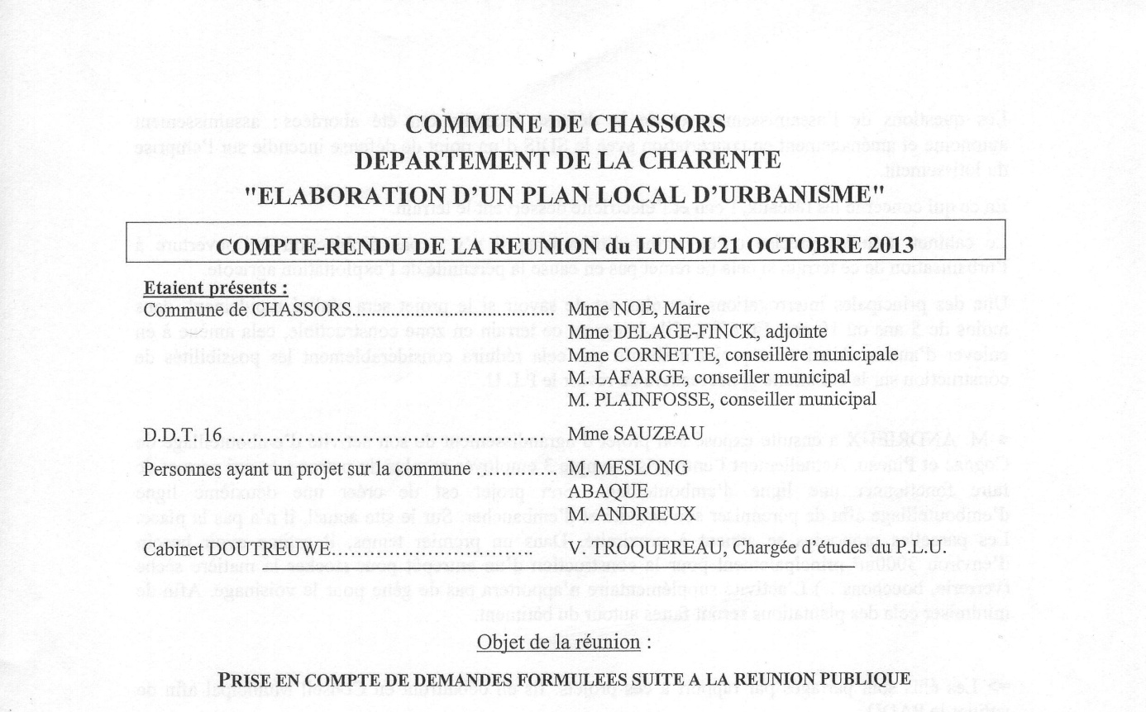
EXTRAITS



